**Instructions for setting up:**

1. **Install python 3 and python-can library**

sudo apt-get install python3-pip

sudo pip3 install python-can

1. **Install compatible gcc g++ version**

mkdir ~/Downloads/gcc-4.9-deb && cd ~/Downloads/gcc-4.9-deb

wget http://launchpadlibrarian.net/247707088/libmpfr4_3.1.4-1_amd64.deb

wget http://launchpadlibrarian.net/253728424/libasan1_4.9.3-13ubuntu2_amd64.deb

wget http://launchpadlibrarian.net/253728426/libgcc-4.9-dev_4.9.3-13ubuntu2_amd64.deb

wget http://launchpadlibrarian.net/253728314/gcc-4.9-base_4.9.3-13ubuntu2_amd64.deb

wget http://launchpadlibrarian.net/253728399/cpp-4.9_4.9.3-13ubuntu2_amd64.deb

wget http://launchpadlibrarian.net/253728404/gcc-4.9_4.9.3-13ubuntu2_amd64.deb

wget http://launchpadlibrarian.net/253728432/libstdc++-4.9-dev_4.9.3-13ubuntu2_amd64.deb

wget http://launchpadlibrarian.net/253728401/g++-4.9_4.9.3-13ubuntu2_amd64.deb

sudo dpkg -i gcc-4.9-base_4.9.3-13ubuntu2_amd64.deb

sudo dpkg -i libmpfr4_3.1.4-1_amd64.deb

sudo dpkg -i libasan1_4.9.3-13ubuntu2_amd64.deb

sudo dpkg -i libgcc-4.9-dev_4.9.3-13ubuntu2_amd64.deb

sudo dpkg -i cpp-4.9_4.9.3-13ubuntu2_amd64.deb

sudo dpkg -i gcc-4.9_4.9.3-13ubuntu2_amd64.deb

sudo dpkg -i libstdc++-4.9-dev_4.9.3-13ubuntu2_amd64.deb

sudo dpkg -i g++-4.9_4.9.3-13ubuntu2_amd64.deb

sudo update-alternatives --install /usr/bin/gcc gcc /usr/bin/gcc-4.9 100 --slave /usr/bin/g++ g++ /usr/bin/g++-4.9

sudo update-alternatives --install /usr/bin/gcc gcc /usr/bin/gcc-4.9 50

sudo update-alternatives --config gcc g++

**download PEAK Linux driver 8.6.0**

https://www.peak-system.com/Details.114+M5a4777bb44d.0.html?&L=1

tar -xzf peak-linux-driver-8.6.0.tar.gz

cd peak-linux-driver-8.6.0

1. **install required dependencies (peak-driver):**

sudo apt-get install libpopt-dev # build chardev driver

make –C driver NET=NETDEV_SUPPORT

sudo modprobe pcan

1. **check PEAK devices: (**NOTE: if run into error: no command found. Redo step 5 and step 6, but redownloading the peak can driver is not required)

cat /proc/pcan

check if can0 appears on the terminal window as follow

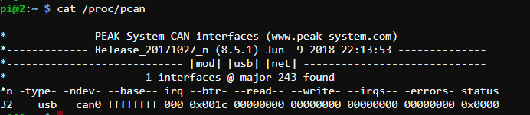

If not, repeat step 6